1 Introduction

To test Modpath’s effectiveness of modeling well capture zones, a comparison of particle tracking results from a modpath simulation were compared to an analytical solution. The analytical solution describes the edge of the capture zone for an unconfined aquifer, as well as the stagnation distance and the shape of capture zone when steady-state conditions have been met (Todd 1980, Grubb 1993).

Test cases

The scenario is, one-layer unconfined aquifer with an extraction well. The well pumps at a constant rate of 2.5 gpm, the hydraulic gradient is approximately 8.16E-4 ft/ft, the hydraulic conductivity is 10 ft/day and the saturated thickness approximately 175 ft. The maximum width of the capture zone (ymax) for an unconfined aquifer is defined by the equation:

Ymax = +/- QL / K(h2^2 - h1^2)

Where Q is the pumping rate

b is the initial saturated thickness

K is the hydraulic conductivity

L is the distance between

And h1 and h2 are the up-gradient and down-gradient heads.

Ymax for the analytical solution was approximately 160 ft and the stagnation distance is about 51 ft. The stagnation distance and the shape of the curve describing the capture zone are both described in Grubb 1993.

The groundwater model was run with the chprc version of modflow 2000 in steady state. The model dimensions are 40,000 ft by 40,000 ft, with 400 rows by 400 columns. Constant head boundaries were set on both the left and right columns of the model. The left was set to 200 ft and the right was set to 167.35 ft to reproduce the values used in the analytical solution. Modpath version 6 was run on top of the groundwater flow model. The model had a well placed in cell 201, 311 that was extracting at a rate of 2.5 gpm. In the forward simulation particles were placed in a series of rows approximately 4000 ft to the left of the well, pathlines were created to observe the particles moving (fig 1). A second case mopdath model was run backwards where 20 particles were placed equally along the right well cell (fig 2).

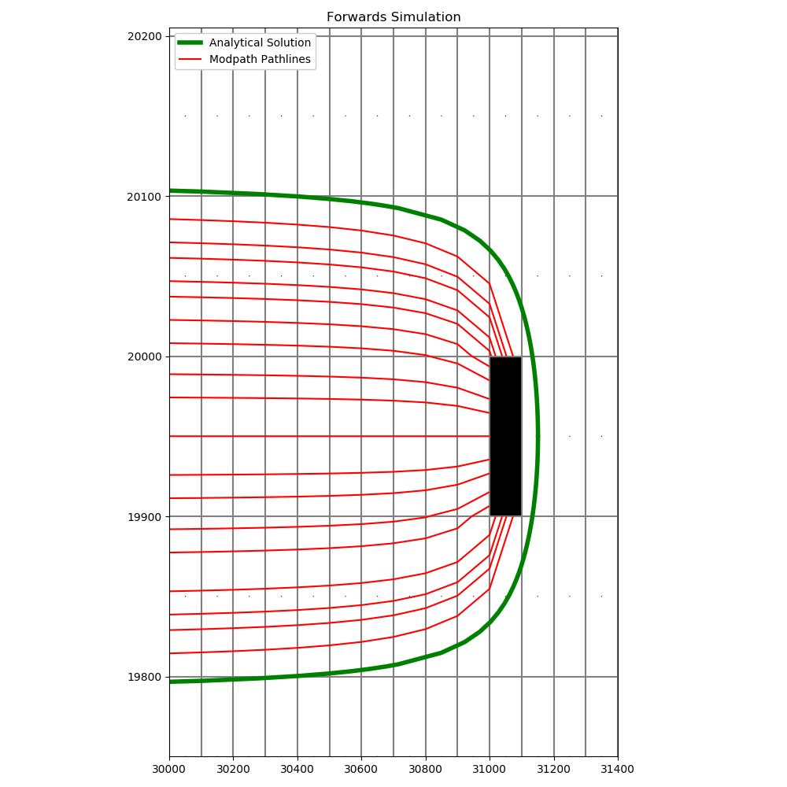

Figure

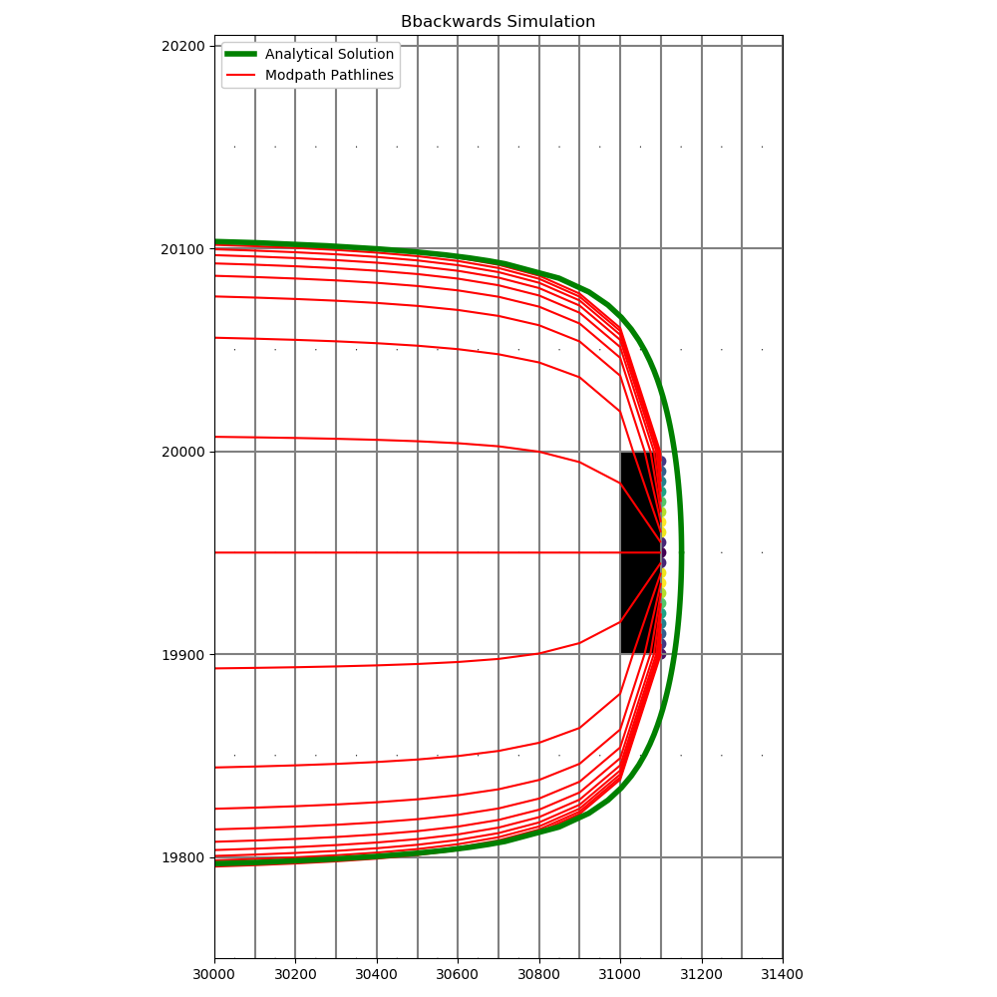

The results are very similar to the analytical solution in forward where the stagnation distance was well defined.

Conclusion

All particles that were placed within the ymax of the analytical solution were captured by the well in the forawd simulation. The backwards simulation (fig 2) shows that all particles that started in the well cell remain in the capture zone (+/-160 ft in the y direction). In the backwards simulation, the pathlines converge with the analytical solution but notably, the stagnation distance was not defined in either simulation, and particles leaving the well cell went towards the left portion.